**Project 3**

**Launch an EC2 Instance with Lambda**

Create an IAM Policy

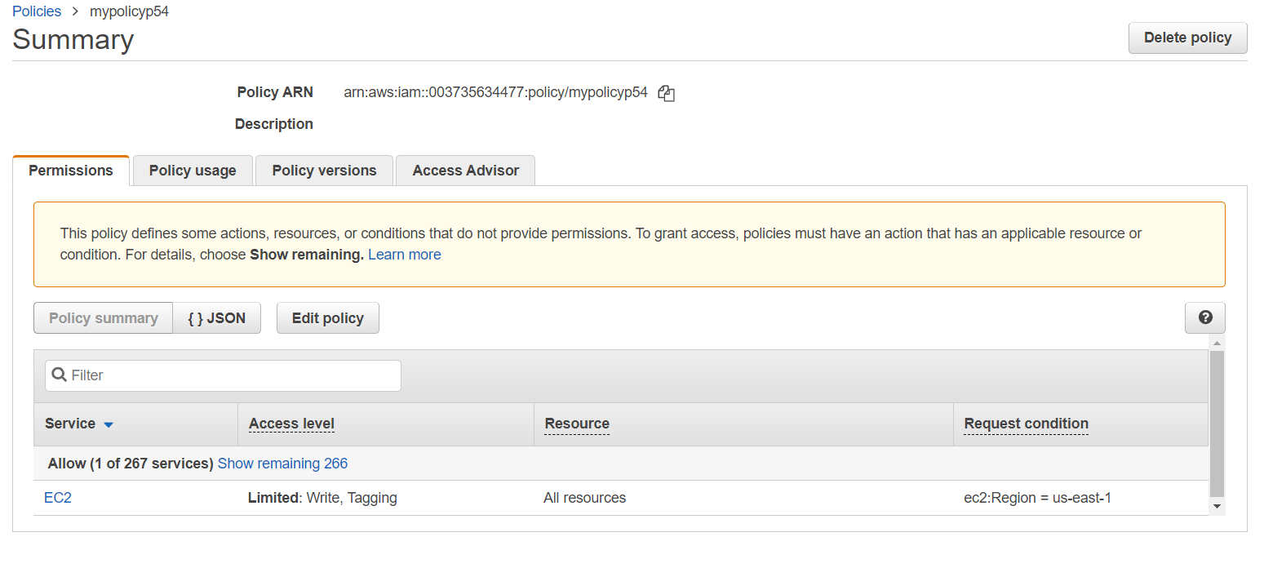

Create an IAM Role

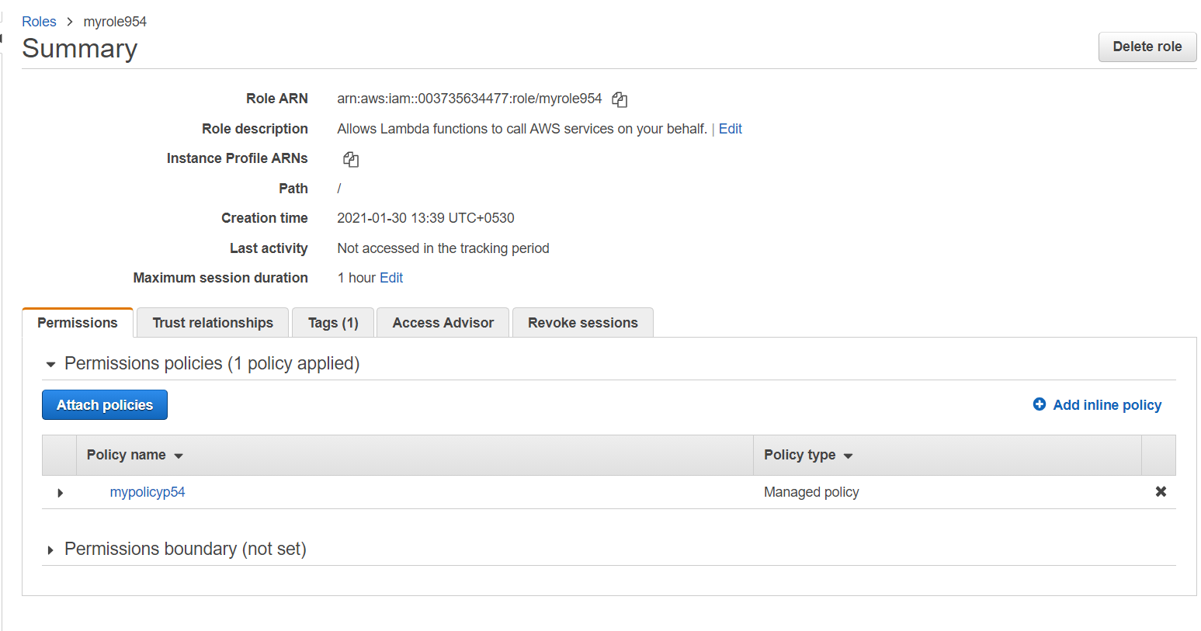

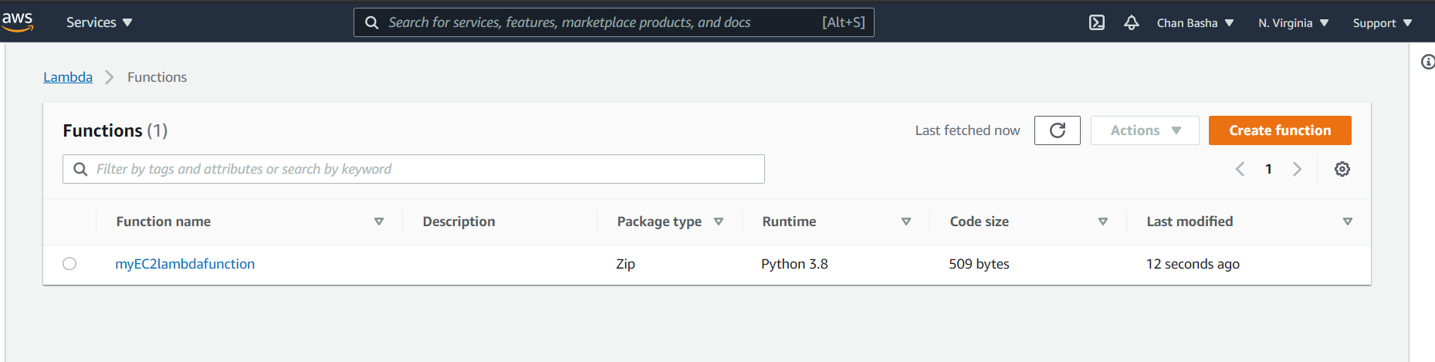

Create a Lambda Function

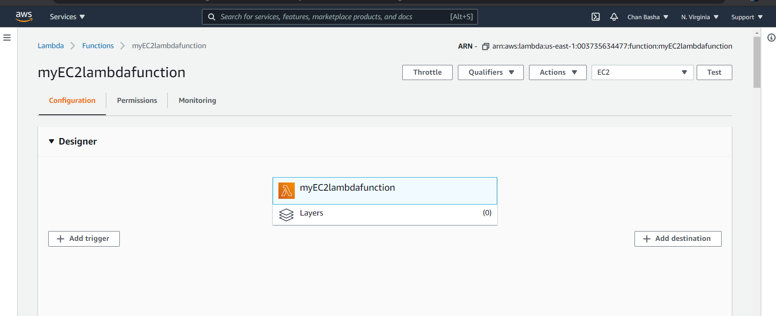

Status of Lambda successful

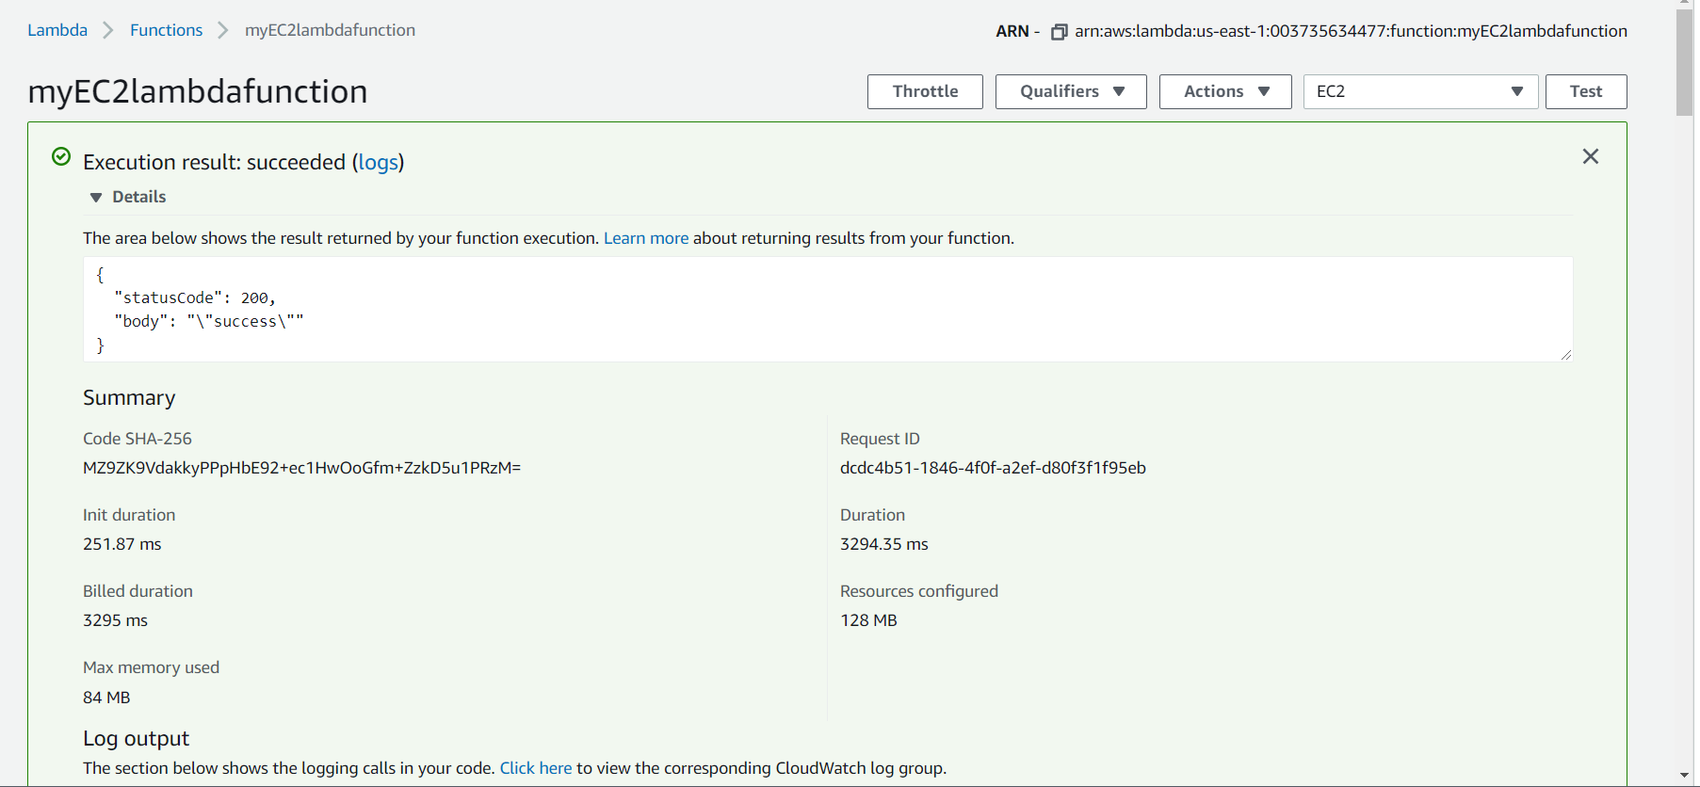

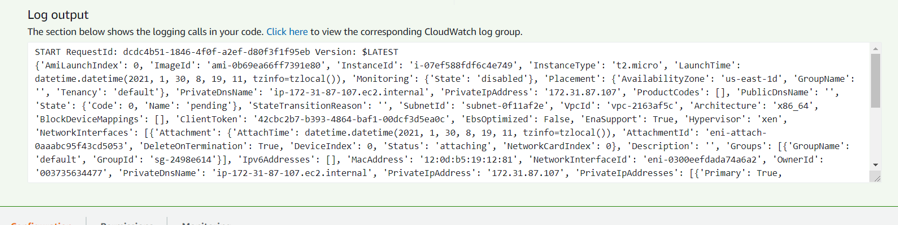

Creating EC2 instance by Lambda Function

